Chapter 2׃ What Does it Mean?

Tujuh Pembelajaran:

Setelah mempelajari Bab 2, siswa diharapkan mampu:


- Mensyukuri kesempatan dapat mempelajari bahasa Inggris sebagai bahasa pengantar komunikasi International yang diwujudkan dalam semangat belajar.

2.1 | Menunjukkan perilaku santun dan peduli dalam
 | melaksanakan komunikasi interpersonal dengan guru
 | dan teman.
2.2 | Menunjukkan perilaku jujur, disiplin, percaya diri,
 | dan bertanggung jawab dalam melaksanakan
 | komunikasi transaksional dengan guru dan teman.
2.3 | Menunjukkan perilaku tanggung jawab, peduli,
 | kerjasama, dan cinta damai, dalam melaksanakan
 | komunikasi fungsional.
3.5 | Menganalisis fungsi sosial, struktur teks, dan unsur
 | kebahasaan dari teks penyerta gambar (caption), sesuai
 | dengan konteks penggunaannya.

4.7

4.8

Menangkap makna teks penyerta gambar.

Menyusun teks penyerta gambar, dengan memperhatikan fungsi sosial, struktur teks, dan unsur kebahasaan yang benar dan sesuai konteks.


Bahasa Inggris | 15

A. WARMER: Video Watching


Work in pairs. Your teacher will show you a fragment of a mute film, so you can see the actions but you cannot hear the voices. What you should do is guessing what is said by the characters in the film. Your teacher will pause in certain points to give you time to write down the possible conversations between the speakers.

B. OBSERVING AND QUESTIONING

Task 1: Observe and Discuss.


Now, look at the following pictures.

Discuss with your friends which ones are captions.
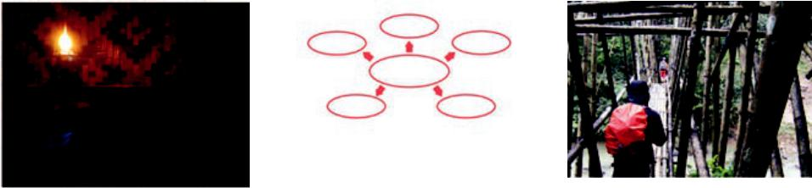


- Kelas XII SMA/MA/SMK/MAK

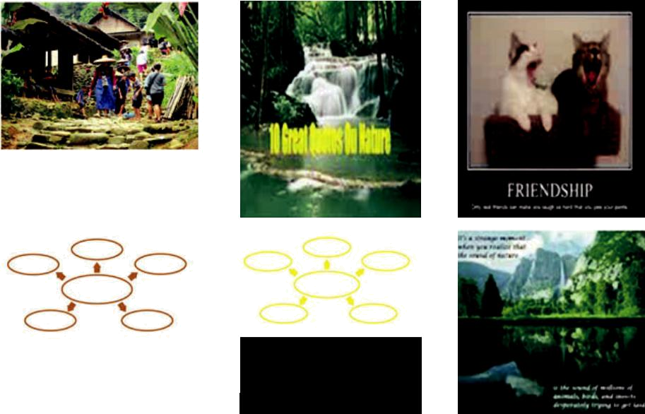

Picture 2.1 Observing pictures' captions



- A caption, also known as a cutline, is text that appears below an image. Most captions draw attention to something in the image that is not obvious, such as its relevance to the text. Captions can consist of a few words of description, or several sentences. Along with the title, the lead, and section headings, captions are the most commonly read words in an article, so they should be succinct and informative (http://en.m.wikipedia.org/ wiki/Wikipedia:ManualofStyle/Captions).

Captions also include a short title or heading of an article in a magazine or newspaper. Words shown on a cinema or television screen to establish the scene of a story are also called captions.
There are several criteria for a good caption. A good caption clearly identifies the subject of the picture without detailing the obvious. It is succinct, establishes the picture's relevance to the article, provides context for the picture, and draws the reader into the article.


Bahasa Inggris | 17

Task 2:

Observe the captions, and answer the questions that follow.
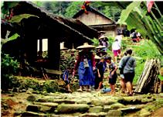

      - Can you mention some attitude problems?
      - What kind of personality that is difficult to handle?
      - What kind of caption is it?

  - Make some quotes about nature.

  - Explain your quotes to your friends.

    - What does friendship mean to you?

    - Write a sentence or phrase under the word friendship above.

- What do you think about the picture? Is the man happy? What does this man symbolize?
- Write your own caption inside the box above.

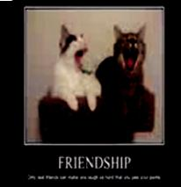


- Kelas XII SMA/MA/SMK/MAK

C. COLLECTING INFORMATION

Task 1: Discuss and Write.
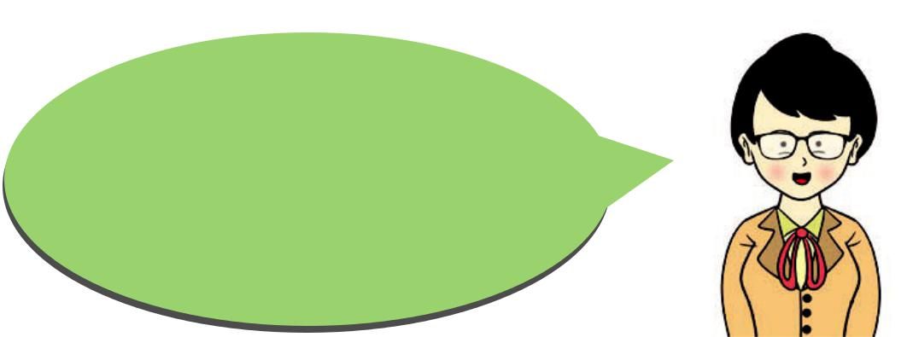

Back again to the captions above. Discuss what messages are sent by the writer? Write down your answer in the space below.


Caption | Message
Caption 1 | The The writer wants to show the beauty of the
Caption 1 | flowers resulted from the violet color.
Caption 2
Caption 3
Caption 4
Caption 5
Caption 6
Caption 7
Caption 8

Bahasa Inggris | 19

Task 2: Pairwork.

Referring to the pictures above, complete the blanks with suitable expressions. Then, play the roles of the speakers in the pictures.

A : Which caption(s) do you like?

B : ..........................................................................

A : Why do you think so?

B : ..........................................................................

What about you, which one(s) do you like?

A : I think..........................................................................

B : Can you tell me why you like it?

A : ..........................................................................

A : Which .....................................................?

B : I like caption number 4. The font is so interesting

and the combination of black and white color

provides a clear contrast. What about you, which one

do you like the best?

B : I like number 5 best. The yellow color with the

greeny nature background …………………………….....

......………………….......................................................

B : I like it, too. The words are also.....................................

...................................................................................

Continue having a chat with your friends about each of the captions above. Express your opinions to your friends and respond to their opinions.

- Kelas XII SMA/MA/SMK/MAK

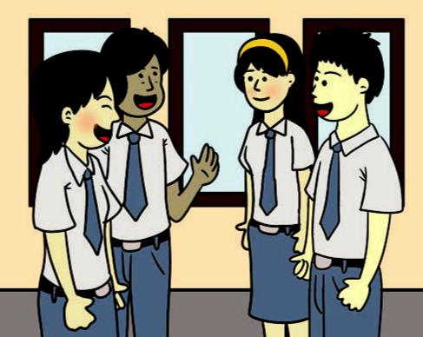

D. ASSOCIATING


Work in groups. Find two captions. Discuss with your friends by focusing on three things:

- whether they are good, 2) what messages they express, and 3) what grammar is used.


- A note to remember:

There are several criteria for a good caption. A good caption clearly identifies the subject of the picture without detailing the obvious. It is succinct, establishes the picture's relevance to the picture, provides context for the picture, and draws the reader into the message.

So related to the structure of a caption, it can be written in the form a word(s), a phrase(s) or a sentence(s).

Bahasa Inggris | 21

E. COMMUNICATING

Writing and Describing Captions

When writing a caption, the descriptive words should offer more complete information about the picture. The words that you choose depends on the message that you want to send to your readers.

Task 1: Read the instruction and listen to your teacher.

Look at the following picture and create a caption using the picture. Look at the example below:
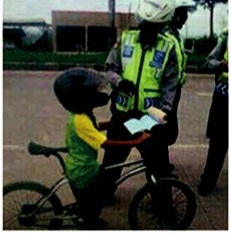

Picture 2.2 Observing pictures' captions

From the picture above, you can create different kinds of caption. You can write ‘poor boy’ to show your sympathy to the boy. You can also write down, “Show me your driving license” to create a satire commenting on the police officer. You might want to write, “Oh, my goodness,” to echo the boy’s mind why the police should stop him while he is only riding his bycicle or the police is thinking why the boy wear the safety helmet for motor rider. Many other expressions are possible. You can also put the words in different positions to create the best layout.

- Kelas XII SMA/MA/SMK/MAK

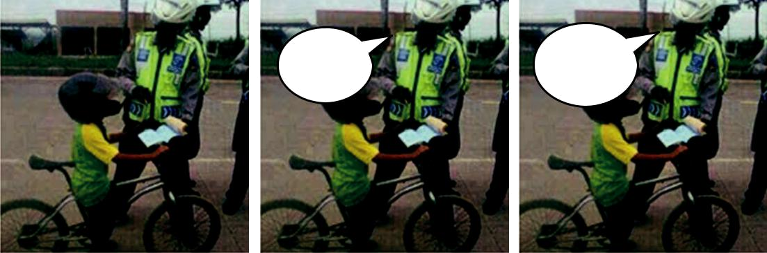
 | Oh, my
 | Oh, my | Show me your
goodness |  | driving lisence

Task 2: Work in Groups.


Now, sit in groups of four. Take your picture that you have brought from home and copied into four.
Distribute them to your friends and ask them to write

a caption on each picture.
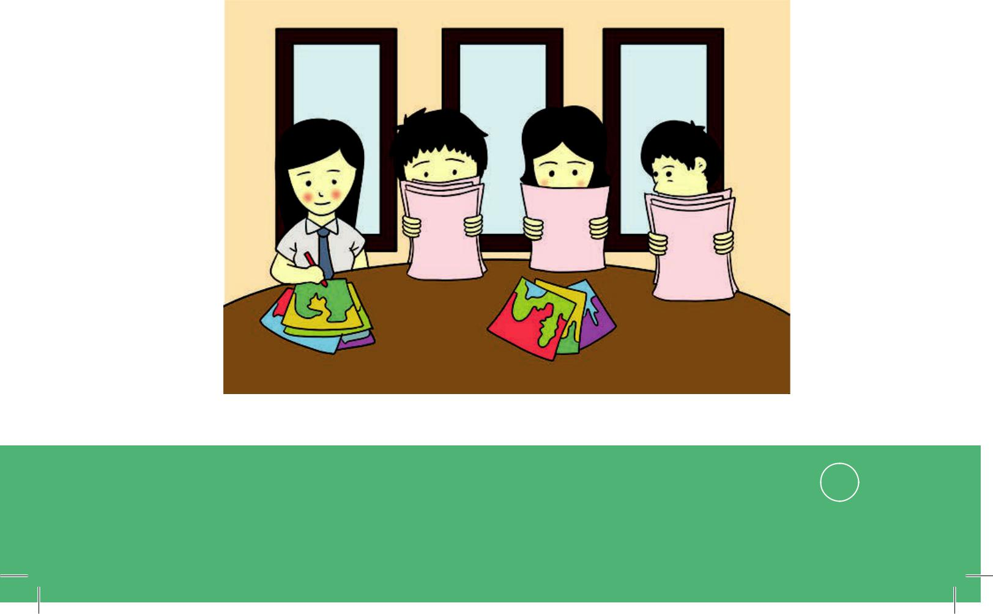

Bahasa Inggris | 23

- Activities in Group. How Do You Do It?

The first student will start by distributing a copy of his or her caption to each student in the group. All students then write a caption of the same picture. After that, the students show the caption to their friends and explain the message in it. The second, third and fourth students repeat the process.

- Kelas XII SMA/MA/SMK/MAK

R E F L E C T I O N
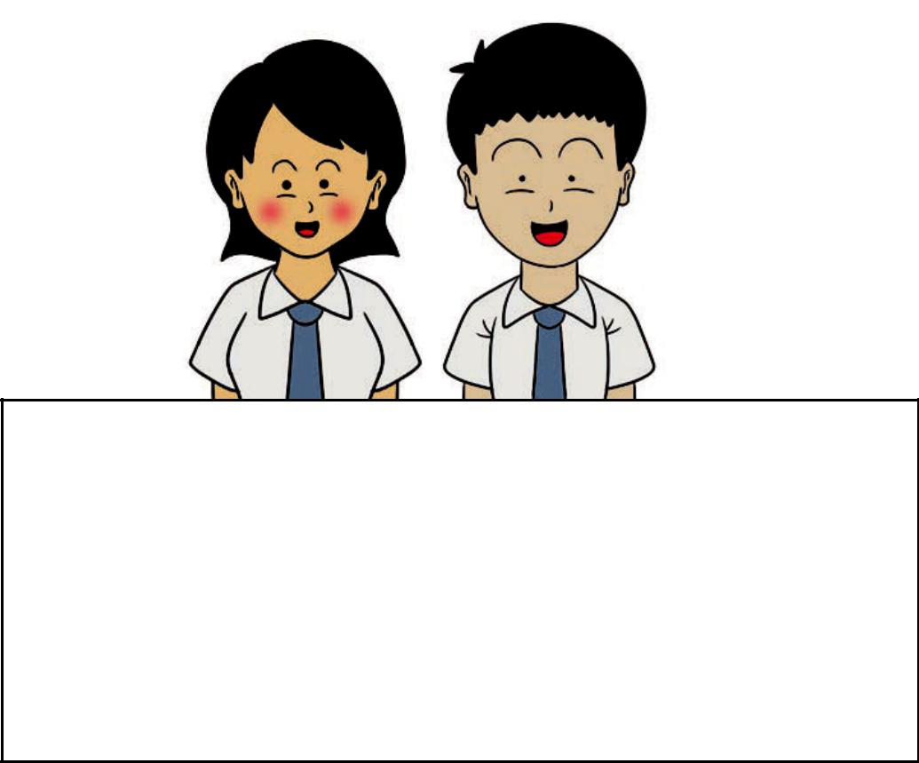

- Do you know the social function of captions?

- Do you know what the structure and language features used in captions?
- Do you understand the message in captions?

- Do you know how to write text accompanying captions?

Bahasa Inggris | 25

